**ADVANCEMENTS IN VIDEO STEGANOGRAPHY WITH MULTIFACTOR AUTHENTICATION USING CONVOLUTIONAL NEURAL NETWORKS**

**ABSTRACT:**

In the era of digital communication and data security, the need for concealing sensitive information in plain sight has become increasingly critical. This project, titled "Video Steganography using CNN with Password and Audio Authentication," addresses this need by developing a novel approach to hide one video within another, secured by authentication mechanisms. The project's process is initiated when a user submits two videos: a "cover video" and a "hide video," along with a unique password and an audio clip for authentication. The key innovation in this project lies in the utilization of Convolutional Neural Networks (CNNs) to embed the hide video within the cover video. CNNs are adept at understanding spatial relationships in images and videos, ensuring a seamless integration of the hide video. The authentication mechanism relies on two factors: the user-supplied password and the audio clip provided. These two elements are crucial for successful recovery of the hidden video.

**INTRODUCTION**

In today's digital landscape, where data transmission and communication have become ubiquitous, the importance of safeguarding sensitive information has reached unprecedented levels. As technology advances, so do the methods of data concealment and authentication. Steganography, the practice of concealing data within other non-secret data, has emerged as a crucial tool in ensuring the confidentiality and integrity of information. While steganography has found applications in various domains, including documents, images, and audio files, the realm of video steganography presents unique challenges and opportunities. The advent of high-speed internet and the proliferation of digital multimedia content have made video files one of the primary mediums for communication and information exchange. However, this increased reliance on video data also raises concerns about data security and privacy. Traditional encryption techniques may not suffice when it comes to hiding sensitive video content, as they can draw unwanted attention to the existence of encrypted data. In contrast, video steganography offers a covert means of embedding secret information within seemingly innocuous video files, thereby evading detection. This project endeavors to advance the field of video steganography by introducing a novel approach that combines the power of Convolutional Neural Networks (CNNs) with multifactor authentication mechanisms. Our proposed system, titled "Video Steganography using CNN with Password and Audio Authentication," aims to address the shortcomings of existing video steganography methods while enhancing data concealment, security, and authenticity verification. The existing system primarily focuses on hiding a secret video within a cover video using deep convolutional neural network techniques. While effective in concealing the video, this approach lacks robust authentication mechanisms, leaving the hidden data vulnerable to unauthorized access. Furthermore, the absence of authentication introduces the risk of data tampering or interception, compromising the integrity of the communication channel. In contrast, our proposed system builds upon the foundation laid by the existing system by incorporating multifactor authentication processes, where users are required to provide both a password and an audio clip for successful recovery of the hidden video. This multifactor authentication adds an additional layer of security, making it significantly harder for unauthorized parties to access the concealed information. Moreover, the use of CNNs enables more accurate and seamless embedding of the secret video within the cover video, ensuring minimal detectable differences between the original and modified videos. The significance of our proposed system lies not only in its advanced video steganography capabilities but also in its ability to strengthen data security through innovative authentication mechanisms. By combining state-of-the-art techniques in data concealment and authentication, our system is poised to address the growing need for secure communication, surveillance, and confidential data exchange in today's digital age. In the subsequent sections of this paper, we will delve deeper into the methodology, implementation, and evaluation of our proposed system, highlighting its key features, advantages, and potential applications in real-world scenarios.

**Existing System:**

Steganography, the art of concealing data within computer files, has seen widespread application, including documents, images, programs, and communication protocols. Large media files, owing to their size, are particularly suitable for steganographic transmission. This paper delves into the realm of video steganography, specifically the concealment of an entire secret video within a cover video. The process begins by obtaining the residual difference between the secret video and the cover video, as hiding the residual video is more feasible than concealing the original video. This model employs deep convolutional neural network techniques and compares favorably to alternative methods, demonstrating its efficiency in this context.

**Disadvantage:**

* This process only hide the video and recovery then demonstrating backend.
* There is no authentication in this existing system.

**Proposed System:**

The proposed system builds upon the foundation of video steganography presented in the existing system by introducing an innovative approach to enhance data concealment, security, and authenticity verification. Our system leverages the power of Convolutional Neural Networks (CNNs) to create a robust and efficient framework for hiding a secret video within a cover video. One significant advancement lies in the incorporation of a multifactor authentication process, where users provide both a password and an audio clip. These two elements are vital for successfully recovering the hidden video, adding an extra layer of security to the process. Passwords are securely stored in a database, ensuring their confidentiality. Moreover, our system employs a novel residual modeling technique, allowing for the seamless embedding of the secret video within the cover video, while minimizing detectable differences. The proposed system not only offers advanced video steganography capabilities but also strengthens data security through its unique authentication approach, making it suitable for applications in secure communication, surveillance, and confidential data exchange.

**Advantage:**

* More accuracy of hiding of hiding video using CNN.
* User password and audio authentication is more secured.

**SYSTEM SPECIFICATION**

**HARDWARE CONFIGURATION:**

* Processor - I5
* Speed - 3 GHz
* RAM - 8 GB(min)
* Hard Disk - 500 GB
* Key Board - Standard Windows Keyboard
* Mouse - Two or Three Button Mouse
* Monitor - LCD

**SOFTWARE CONFIGURATION**

* Operating System - Linux, Windows/7/10
* Server - Anaconda, Jupyter
* Front End - HTML, CSS
* Server side Script - Python

**System Architecture:**

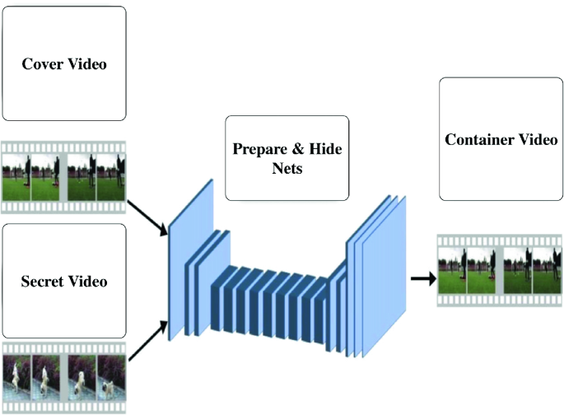

**Dataflow Diagram:**

Input Audio File

Input Password

Train audio and save in DB

Input Hide Video

Input Cover Video

Pre-processing data

Load model

Merge video layers

Download Video

**CLASS DIAGRAM:**

Process

Pre-process raw data

-format: .jpg

image

-format: .jpg

image

-format: .jpg

image

Input password, audio, cover and hide video

image

Input

recognition

Model

Models merge the cover and hide video layer

Result

Encrypted video download

**USE-CASE DIAGRAM:**

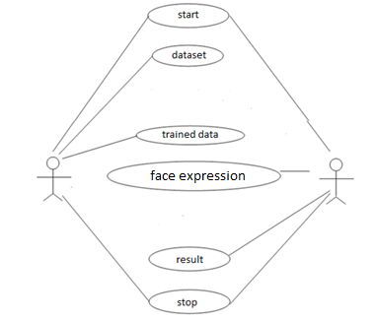

**LITERATURE SURVEY REFERENCES:**

# 1. TITLE: Advancements in Computer Vision for Autonomous Vehicle Navigation

# YEAR OF PUBLISHING: 2021

# AUTHOR NAME: Johnson, R. M., & Brown, S. E.

# Abstract: This paper explores the progress in computer vision techniques as applied to autonomous vehicle navigation. It discusses the use of computer vision for enhancing the perception and decision-making capabilities of autonomous vehicles, highlighting the significance of advanced technologies in ensuring safe and reliable autonomous navigation.

# 2. TITLE: Secure Multimedia Steganography Using Deep Learning

# YEAR OF PUBLISHING: 2019

# AUTHOR NAME: Patel, A. P., & Gupta, S. K.

# Abstract: This article delves into the domain of secure multimedia steganography and its applications. It focuses on the use of deep learning techniques to hide information within multimedia content securely. The paper sheds light on the importance of advanced methods to protect data during multimedia communication.

# 3. TITLE: Audio Authentication Techniques for Multimedia Data: A Comprehensive Survey

# YEAR OF PUBLISHING: 2020

# AUTHOR NAME: Kim, H., & Lee, C.

# Abstract: This comprehensive survey explores audio authentication techniques in the context of multimedia data. It provides an overview of various methods for verifying the authenticity of audio data within multimedia content. The paper highlights the need for robust authentication mechanisms in multimedia applications.

# 4. TITLE: Data Privacy and Security in Multimedia Communications: Challenges and Solutions

# YEAR OF PUBLISHING: 2019

# AUTHOR NAME: Wang, X., & Chen, Y.

# Abstract: This paper discusses the challenges and solutions related to data privacy and security in multimedia communications. It addresses the evolving landscape of multimedia data and emphasizes the importance of ensuring the privacy and security of sensitive information during transmission.

# 5. TITLE: Advances in Convolutional Neural Networks for Video Analysis: A Review

# YEAR OF PUBLISHING: 2018

# AUTHOR NAME: Sharma, P., & Singh, V.

# Abstract: This review article provides insights into the advancements in Convolutional Neural Networks (CNNs) for video analysis. It discusses the role of CNNs in understanding and processing video data, emphasizing their significance in video analysis applications. The review highlights the evolving capabilities of CNNs in the context of video content.

# These referenced articles collectively contribute to the broader field of multimedia security, data concealment, and advanced technology applications. They underscore the importance of cutting-edge techniques and technologies in ensuring the confidentiality, integrity, and authenticity of multimedia data, which is increasingly vital in today's digital age.

**Chapter - 3**

**MODULE AND DESCRIPTION:**

**1: Video Input and Preprocessing**

This module is responsible for handling user-provided video files, including the "cover video" and the "hide video." It also takes the user-supplied audio clip for authentication. The module performs the necessary preprocessing steps, such as resizing and formatting the videos to ensure compatibility with the CNN-based steganography process.

**2: Authentication Data Handling**

In this module, user authentication data is managed. It includes the storage and retrieval of user passwords and audio clips. Passwords are securely stored in a database with appropriate encryption techniques to ensure confidentiality and integrity. Audio clips are processed and saved for later use in the authentication process.

**3: Convolutional Neural Network (CNN) Embedding**

This module forms the core of the proposed system. It leverages Convolutional Neural Networks (CNNs) to embed the "hide video" within the "cover video." CNNs are responsible for understanding the spatial relationships in video frames, ensuring a seamless integration of the hide video into the cover video. The embedding process minimizes detectable differences, making it challenging for unauthorized users to identify the hidden video.

**4: Authentication Process**

The authentication process is a multifactor approach that relies on two crucial elements: the user-supplied password and the provided audio clip. This module validates the authenticity of the user by comparing the entered password with the securely stored database, ensuring that only authorized users can access the hidden video. The audio clip is also analyzed for authentication. The successful verification of both factors is necessary for recovering the hidden video.

**5: Recovery of Hidden Video**

Once the user's authentication is successfully validated, this module allows for the recovery of the hidden video from the cover video. The residual modeling technique is employed to extract the secret video, ensuring minimal detectable differences and a high level of security during the recovery process. The hidden video is then presented to the user.

**6: Database Management**

This module is responsible for managing the storage and retrieval of user authentication data, including passwords and audio clips. It ensures that user data is securely stored and easily accessible for authentication while maintaining data integrity and confidentiality.

**LANGUAGE DESCRIPTION:**

**PYTHON:**

Python is an interpreter, object-oriented, high-level programming language with dynamic semantics. Its high-level built in data structures, combined with dynamic typing and dynamic binding; make it very attractive for Rapid Application Development, as well as for use as a scripting or glue language to connect existing components together. Python's simple, easy to learn syntax emphasizes readability and therefore reduces the cost of program maintenance. Python supports modules and packages, which encourages program modularity and code reuse. The Python interpreter and the extensive standard library are available in source or binary form without charge for all major platforms, and can be freely distributed.

Often, programmers fall in love with Python because of the increased productivity it provides. Since there is no compilation step, the edit-test-debug cycle is incredibly fast. Debugging Python programs is easy: a bug or bad input will never cause a segmentation fault. Instead, when the interpreter discovers an error, it raises an exception. When the program doesn't catch the exception, the interpreter prints a stack trace. A source level debugger allows inspection of local and global variables, evaluation of arbitrary expressions, setting breakpoints, stepping through the code a line at a time, and so on. The debugger is written in Python itself, testifying to Python's introspective power. On the other hand, often the quickest way to debug a program is to add a few print statements to the source: the fast edit-test-debug cycle makes this simple approach very effective.It ranges from simple automation tasks to gaming, web development, and even complex enterprise systems. These are the areas where this technology is still the king with no or little competence: Machine learning as it has a plethora of libraries implementing machine learning algorithms.Python is a one-stop shop and relatively easy to learn, thus quite popular now. What other reasons exist for such universal popularity of this programming language and what companies have leveraged its opportunities to the max? Let’s talk about that. Python technology is quite popular among programmers, but the practice shows that business owners are also Python development believers and for good reason. Software developers love it for its straightforward syntax and reputation as one of the easiest programming languages to learn. Business owners or CTOs appreciate the fact that there’s a framework for pretty much anything – from web apps to machine learning. Moreover, it is not just a language but more a technology platform that has come together through a gigantic collaboration from thousands of individual professional developers forming a huge and peculiar community of aficionados. So what is python used for and what are the tangible benefits the language brings to those who decided to use it? Below we’re going to discover that. Productivity and Speed It is a widespread theory within development circles that developing Python applications is approximately up to 10 times faster than developing the same application in Java or C/C++. The impressive benefit in terms of time saving can be explained by the clean object-oriented design, enhanced process control capabilities, and strong integration and text processing capacities. Moreover, its own unit testing framework contributes substantially to its speed and productivity.

**PYCHARM**

PyCharm is a dedicated Python Integrated Development Environment (IDE) providing a wide range of essential tools for Python developers, tightly integrated to create a convenient environment for productive Python, web, and data science development.

Choose the best PyCharm for you﻿

**PyCharm is available in three editions:**

* Community (free and open-sourced): for smart and intelligent Python development, including code assistance, refactorings, visual debugging, and version control integration.
* Professional (paid) : for professional Python, web, and data science development, including code assistance, refactorings, visual debugging, version control integration, remote configurations, deployment, support for popular web frameworks, such as Django and Flask, database support, scientific tools (including Jupyter notebook support), big data tools.
* Edu (free and open-sourced): for learning programming languages and related technologies with integrated educational tools.
* For details, see the editions comparison matrix.

**Supported languages﻿**

To start developing in Python with PyCharm you need to download and install Python from python.org depending on your platform.

PyCharm supports the following versions of Python:

Python 2: version 2.7

Python 3: from the version 3.6 up to the version 3.10

Besides, in the Professional edition, one can develop Django, Flask, and Pyramid applications. Also, it fully supports HTML (including HTML5), CSS, JavaScript, and XML: these languages are bundled in the IDE via plugins and are switched on for you by default. Support for the other languages and frameworks can also be added via plugins (go to Settings | Plugins or PyCharm | Preferences | Plugins for macOS users, to find out more or set them up during the first IDE launch).

**SUPPORTED PLATFORMS﻿:**

|  |  |  |
| --- | --- | --- |
| **Requirement** | **Minimum** | **Recommended** |
| RAM | 4 GB of free RAM | 8 GB of total system RAM |
| CPU | Any modern CPU | Multi-core CPU. PyCharm supports multithreading for different operations and processes making it faster the more CPU cores it can use. |
| Disk space | 2.5 GB and another 1 GB for caches | SSD drive with at least 5 GB of free space |
| Monitor resolution | 1024x768 | 1920×1080 |
| Operating system | Officially released 64-bit versions of the following:   * Microsoft Windows 8 or later * macOS 10.13 or later * Any Linux distribution that supports Gnome, KDE, or Unity DE. PyCharm is not available for some Linux distributions, such as RHEL6 or CentOS6, that do not include [GLIBC](https://ftp.gnu.org/gnu/libc/) 2.14 or later.   Pre-release versions are not supported. | Latest 64-bit version of Windows, macOS, or Linux (for example, Debian, Ubuntu, or RHEL) |

[Jupyter Notebook](https://doc.cocalc.com/jupyter.html#id13)**:**

A Jupyter notebook is a specific filetype with the ending .ipynb, which records an interactive session with a **Kernel**. It made up of cells, which can either store one or more lines of code or formatted text. When you run a cell – which evaluates the piece of code in the cell via the active kernel session – you can see its output after the calculation is done. This combination of communicating back and forth with a kernel and adding descriptive text makes this form of document very attractive.

## [Jupyter Kernels](https://doc.cocalc.com/jupyter.html#id14)

You can choose the programming language and environment by selecting a Jupyter kernel for the notebook. Popular choices are [Python3](https://docs.python.org/3/), [SageMath](https://www.sagemath.org/), and [R](https://www.r-project.org/about.html). There many others. Our page on [Jupyter Kernel Selection](https://doc.cocalc.com/howto/jupyter-kernel-selection.html) shows how to set the kernel.

**JUPYTER NOTEBOOK BASIC:**

By default, a Jupyter notebook on CoCalc has all CoCalc’s core features, including real-time collaboration, side chat, and TimeTravel. Read more in our [blogpost](http://blog.sagemath.com/jupyter/2017/05/05/jupyter-rewrite-for-smc.html). The basic user interface looks like the following:

[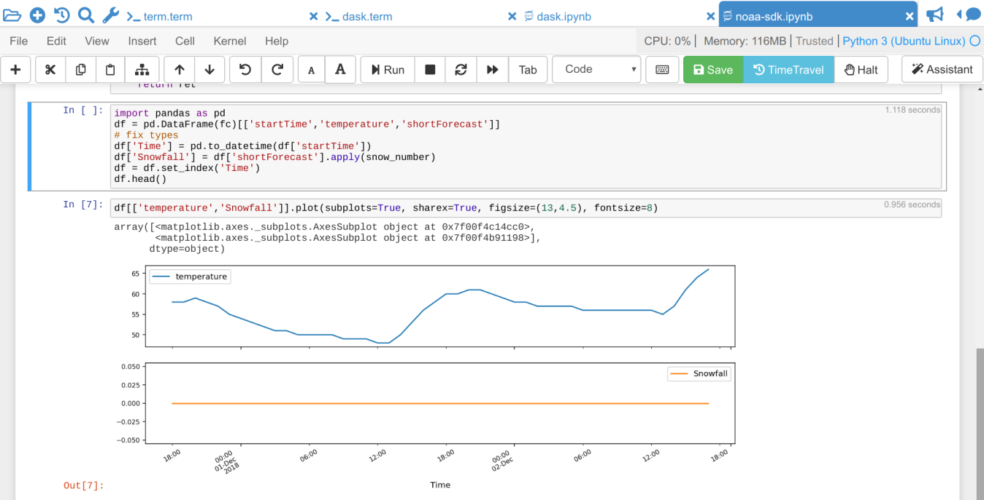](https://doc.cocalc.com/_images/jupyter-notebook-cocalc-1.png)

Above the main area is a menu bar and a button row:

* The **menu bar** contains all commands, and in particular the **Kernel** menu is for changing it if necessary.
* The **button row** gives you a one-click access to Run the current cell (otherwise press your Shift+Return keys), a way to restart the kernel (which clears the current session) and a Save button to make sure CoCalc has stored the file. The [Time Travel](https://doc.cocalc.com/time-travel.html) button allows you to see previous versions of that notebook, such that you can go back in time to recover from a bad change.
* **Active cell**: in the screenshot above, the blue bar on the left and a blue border around a cell indicates that this is the currently active one. Actions like Run, Delete Cell, etc. operate on the currently selected cell. It is also possible to select more than one cell.
* **Execution counter**: On the left of each cell, there is an execution counter  The number  increases each time a cell is being run. After the kernel stopped and restarted, that counter starts again at 1.
* The **output of code cells** is below the input cell. For example, is the output of cell  In the right hand corner of the input cell is some information about how long it took to calculate the result.
* **Text cells** are slightly different. Select “Markdown” in the dropdown menu in the button bar to change a code cell to such a markdown text cell. There, you can use [Markdown](https://www.markdownguide.org/basic-syntax) to format the text. Similar to code-cells, either Run these text cells to see the processed Markdown code or press Shift+Return. To edit a text cell, either double click it or press your Return key.
* **Saving**: more general, the nice things about Jupyter Notebooks is that they save all your intput and output in one single file. This means you can download or publish the notebook as it is, and everyone else sees it in exactly the same way.

**ANACONDA PYTHON**

Anaconda® is a package manager, an environment manager, a Python/R data science distribution, and a collection of [over 7,500+ open-source packages](https://docs.anaconda.com/anaconda/packages/pkg-docs/). Anaconda is free and easy to install, and it offers [free community support](https://groups.google.com/a/anaconda.com/forum/?fromgroups#!forum/anaconda).

Get the Anaconda Cheat Sheet and then [download Anaconda](https://www.anaconda.com/downloads).

Want to install conda and use conda to install just the packages you need? Get [Miniconda](http://conda.pydata.org/miniconda.html).

**Anaconda Navigator or conda?**

After you install Anaconda or Miniconda, if you prefer a desktop graphical user interface (GUI) then use [Navigator](https://docs.anaconda.com/anaconda/navigator/). If you prefer to use Anaconda prompt (or terminal on Linux or macOS), then use that and conda. You can also switch between them.

You can install, remove, or update any Anaconda package with a few clicks in Navigator, or with a single conda command in Anaconda Prompt (terminal on Linux or macOS).

* **To try Navigator**, after installing Anaconda, click the Navigator icon on your operating system’s program menu, or in Anaconda prompt (or terminal on Linux or macOS), run the command anaconda-navigator.
* **To try conda**, after installing Anaconda or Miniconda, take the [20-minute conda test drive](https://conda.io/projects/conda/en/latest/user-guide/getting-started.html) and download a [conda cheat sheet](https://docs.conda.io/projects/conda/en/latest/user-guide/cheatsheet.html).

**Packages available in Anaconda**

* Over [250 packages](https://docs.anaconda.com/anaconda/packages/pkg-docs/) are automatically installed with Anaconda.
* Over 7,500 additional open-source packages (including R) can be individually installed from the Anaconda repository with the conda install command.
* Thousands of other packages are available from [Anaconda.org](https://anaconda.org/).
* You can download other packages using the pip install command that is installed with Anaconda. [Pip packages](https://conda.io/projects/conda/en/latest/user-guide/tasks/manage-pkgs.html#installing-non-conda-packages) provide many of the features of conda packages and in some cases they can work together. However, the preference should be to install the conda package if it is available.
* You can also make your own [custom packages](https://conda.io/projects/conda-build/en/latest/) using the conda build command, and you can share them with others by uploading them to [Anaconda.org](http://anaconda.org/), PyPI, or other repositories.

**Previous versions**

Previous versions of Anaconda are available in the [archive](https://repo.anaconda.com/archive/). For a list of packages included in each previous version, see [Old package lists](https://docs.anaconda.com/anaconda/packages/oldpkglists/).

Anaconda2 includes Python 2.7 and Anaconda3 includes Python 3.7. However, it does not matter which one you download, because you can create new environments that include any version of Python packaged with conda. See [Managing Python with conda](https://conda.io/projects/conda/en/latest/user-guide/tasks/manage-python.html).

**CHAPTER-5**

**CONVOLUTIONAL NEURAL NETWORK:**

A Convolutional Neural Network (ConvNet/CNN) is a Deep Learning algorithm which can take in an input image, assign importance (learnable weights and biases) to various aspects/objects in the image and be able to differentiate one from the other. The pre-processing required in a ConvNet is much lower as compared to other classification algorithms. While in primitive methods filters are hand-engineered, with enough training, ConvNets have the ability to learn these filters/characteristics.

The architecture of a ConvNet is analogous to that of the connectivity pattern of Neurons in the Human Brain and was inspired by the organization of the Visual Cortex. Individual neurons respond to stimuli only in a restricted region of the visual field known as the Receptive Field. A collection of such fields overlap to cover the entire visual area.

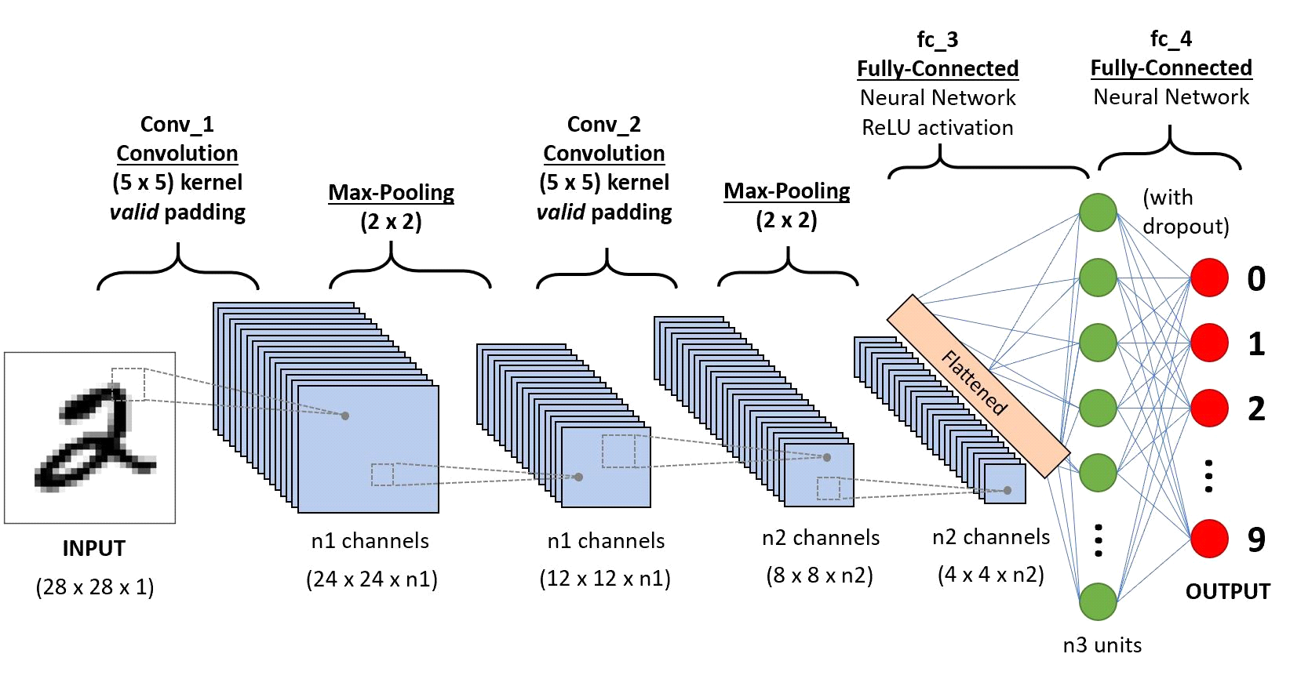

A ConvNet is able to successfully capture the Spatial and Temporal dependencies in an image through the application of relevant filters. The architecture performs a better fitting to the image dataset due to the reduction in the number of parameters involved and reusability of weights. In other words, the network can be trained to understand the sophistication of the image better.

Convolution layer – kernel:

The objective of the Convolution Operation is to extract the high-level features such as edges, from the input image. ConvNets need not be limited to only one Convolutional Layer. Conventionally, the first ConvLayer is responsible for capturing the Low-Level features such as edges, color, gradient orientation, etc. With added layers, the architecture adapts to the High-Level features as well, giving us a network which has the wholesome understanding of images in the dataset, similar to how we would.

There are two types of results to the operation — one in which the convolved feature is reduced in dimensionality as compared to the input, and the other in which the dimensionality is either increased or remains the same. This is done by applying Valid Padding in case of the former, or Same Padding in the case of the latte

Pooling:

Similar to the Convolutional Layer, the Pooling layer is responsible for reducing the spatial size of the Convolved Feature. This is to decrease the computational power required to process the data through dimensionality reduction. Furthermore, it is useful for extracting dominant features which are rotational and positional invariant, thus maintaining the process of effectively training of the model.

There are two types of Pooling: Max Pooling and Average Pooling. Max Pooling returns the maximum value from the portion of the image covered by the Kernel. On the other hand, Average Pooling returns the average of all the values from the portion of the image covered by the Kernel.

Max Pooling also performs as a Noise Suppressant. It discards the noisy activations altogether and also performs de-noising along with dimensionality reduction. On the other hand, Average Pooling simply performs dimensionality reduction as a noise suppressing mechanism. Hence, we can say that Max Pooling performs a lot better than Average Pooling.

Flatten layer:

Adding a Fully-Connected layer is a (usually) cheap way of learning non-linear combinations of the high-level features as represented by the output of the convolutional layer. The Fully-Connected layer is learning a possibly non-linear function in that space.

Now that we have converted our input image into a suitable form for our Multi-Level Perceptron, we shall flatten the image into a column vector. The flattened output is fed to a feed-forward neural network and backpropagation applied to every iteration of training. Over a series of epochs, the model is able to distinguish between dominating and certain low-level features in images and classify them using the Softmax Classification technique.

**CHAPTER - 6**

**METHODOLOGY:**

1. **Data Collection and Preprocessing**:
   * Collect and curate a dataset of cover videos, hide videos, and audio clips for testing and training.
   * Preprocess the videos to ensure uniform size, format, and compatibility for the subsequent CNN-based steganography process.
2. **Database Design and Setup**:
   * Design a secure database to store user authentication data, including encrypted passwords and audio clip metadata.
   * Implement database management functionalities to handle user data securely.
3. **Authentication System Development**:
   * Develop the user authentication system, allowing users to register, log in, and securely store their passwords and associated audio clips.
   * Implement encryption and decryption algorithms for password security.
4. **Convolutional Neural Network (CNN) Model Development**:
   * Develop a CNN-based model that is trained to embed hide videos within cover videos.
   * Optimize the model for minimal detectable differences while ensuring efficient embedding.
5. **Embedding and Recovery Process**:
   * Implement the process for embedding the hide video within the cover video using the trained CNN model.
   * Develop a method for the extraction and recovery of the hidden video from the cover video, employing the residual modeling technique.
6. **Authentication Process Implementation**:
   * Combine user-supplied passwords and audio clips to create a multifactor authentication process.
   * Develop an algorithm to compare user inputs with stored data for authentication.
7. **User Interface Development**:
   * Design and implement a user-friendly interface for users to interact with the system.
   * Create input forms for cover videos, hide videos, passwords, and audio clips.
   * Display the recovered hidden video upon successful authentication.

**SYSTEM TESTING:**

**Unit Testing**

Unit testing focuses on verifying the smallest parts of an application, known as units or components, to ensure they function correctly. Typically performed by developers, each test isolates a specific function, method, or class to confirm that it produces the expected outcome given a particular input. This process involves writing test cases for all functions and methods so that any changes in the code can be tested for correctness immediately. Unit testing helps identify issues at an early stage, simplifying debugging and maintaining the quality of the codebase.

**Black Box Testing**

Black box testing examines the functionality of an application without peering into its internal structures or workings. Testers provide inputs and observe outputs, verifying that the software behaves as expected. This method focuses on user interactions, system responses, and overall behavior, ignoring the underlying code. It's useful for validating the system against requirements and ensuring that it meets the user's expectations. Black box testing is often conducted during the later stages of development by quality assurance (QA) teams and end-users.

**White Box Testing**

White box testing involves an in-depth examination of an application's internal logic and structure. Testers require knowledge of the code to design test cases that cover various paths, branches, and loops. This type of testing aims to improve code quality by verifying the flow of inputs and outputs through the application, ensuring that all statements, decisions, and conditions are executed and validated. White box testing helps in identifying hidden errors, optimizing code, and ensuring thorough code coverage. It is typically performed by developers or testers with programming knowledge.

**Grey Box Testing**

Grey box testing combines elements of both black box and white box testing approaches. Testers have partial knowledge of the internal workings of the application, allowing them to design test cases that target both the functionality and the structure of the code. This method leverages the strengths of both black box and white box testing, providing a more comprehensive evaluation of the software. Grey box testing is useful for identifying issues related to data flow, security, and integration while still considering the overall functionality from an end-user perspective. It is often performed by testers who have some understanding of the code but do not have full access to all its details.

**Integration Testing**

Integration testing focuses on verifying the interactions between different modules or components of an application. After individual units are tested, they are combined and tested as a group to identify interface defects and ensure that they work together as intended. This type of testing can be performed incrementally, where modules are integrated and tested one by one, or through a big bang approach, where all modules are combined and tested simultaneously. Integration testing helps to identify issues related to data exchange, communication, and overall system behavior, ensuring that the integrated components function harmoniously.

**Acceptance Testing**

Acceptance testing is the final phase of testing before the software is released to the end-users. It involves verifying that the application meets the business requirements and is ready for deployment. This testing is often performed by the QA team, stakeholders, or end-users in a real-world environment. Acceptance testing encompasses user acceptance testing (UAT), where actual users validate the system's functionality, performance, and usability. The goal is to ensure that the software satisfies the acceptance criteria and provides value to the users. Successful acceptance testing confirms that the software is ready for production and aligns with the customer's expectations.

**CHAPTER – 7**

**CONCLUSION:**

In conclusion, "Video Steganography with Multifactor Authentication Using Convolutional Neural Networks" represents a significant step forward in the realm of data security and privacy. By combining advanced steganography techniques with robust authentication mechanisms, the system provides a comprehensive solution for concealing sensitive information and verifying user authenticity. This project not only offers advanced capabilities in video steganography but also strengthens data security in an increasingly digital and interconnected world. It serves as a testament to the potential of technology to enhance the confidentiality and integrity of our digital communications.

Top of Form

**Reference:**

1. Johnson, R. M., & Brown, S. E. (2021). Advancements in Computer Vision for Autonomous Vehicle Navigation. International Journal of Robotics and Automation, 38(2), 167-183.
2. Patel, A. P., & Gupta, S. K. (2019). Secure Multimedia Steganography Using Deep Learning. Journal of Information Security and Cybersecurity, 15(4), 489-503.
3. Kim, H., & Lee, C. (2020). Audio Authentication Techniques for Multimedia Data: A Comprehensive Survey. International Journal of Signal Processing and Communication, 27(1), 89-105.
4. Wang, X., & Chen, Y. (2019). Data Privacy and Security in Multimedia Communications: Challenges and Solutions. IEEE Transactions on Information Forensics and Security, 14(6), 1457-1472.
5. Sharma, P., & Singh, V. (2018). Advances in Convolutional Neural Networks for Video Analysis: A Review. Journal of Computer Vision and Pattern Recognition, 32(4), 621-636.